# CSE 6140 / CX 4140

**Computational Science and Engineering Algorithms**

# Homework 5

1. (25 points)

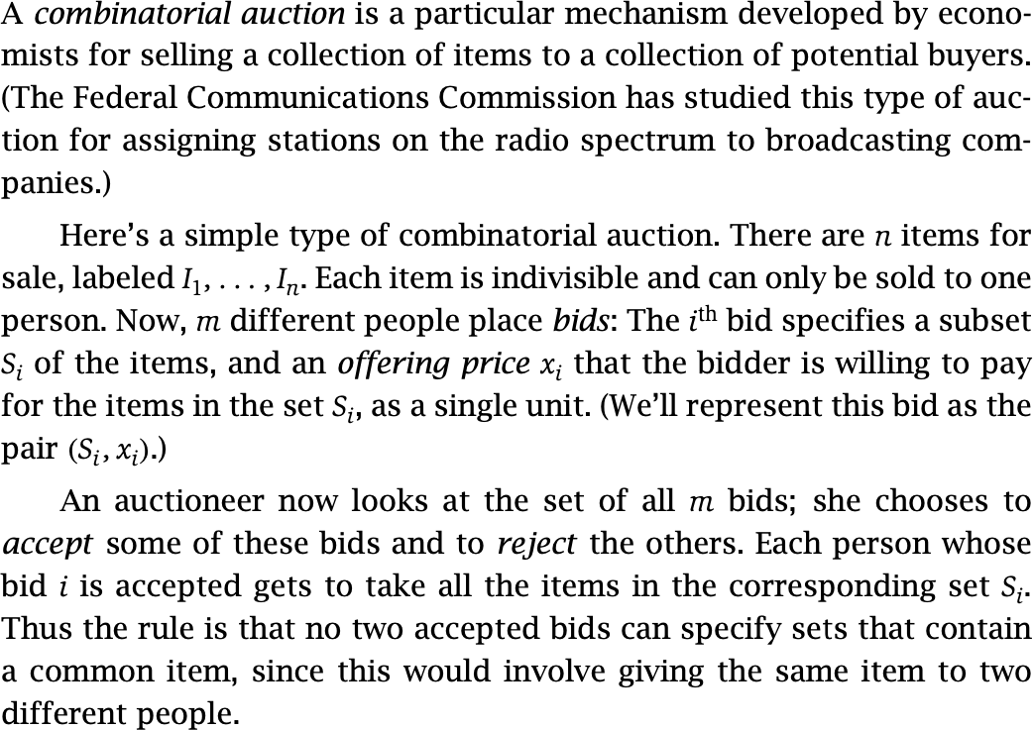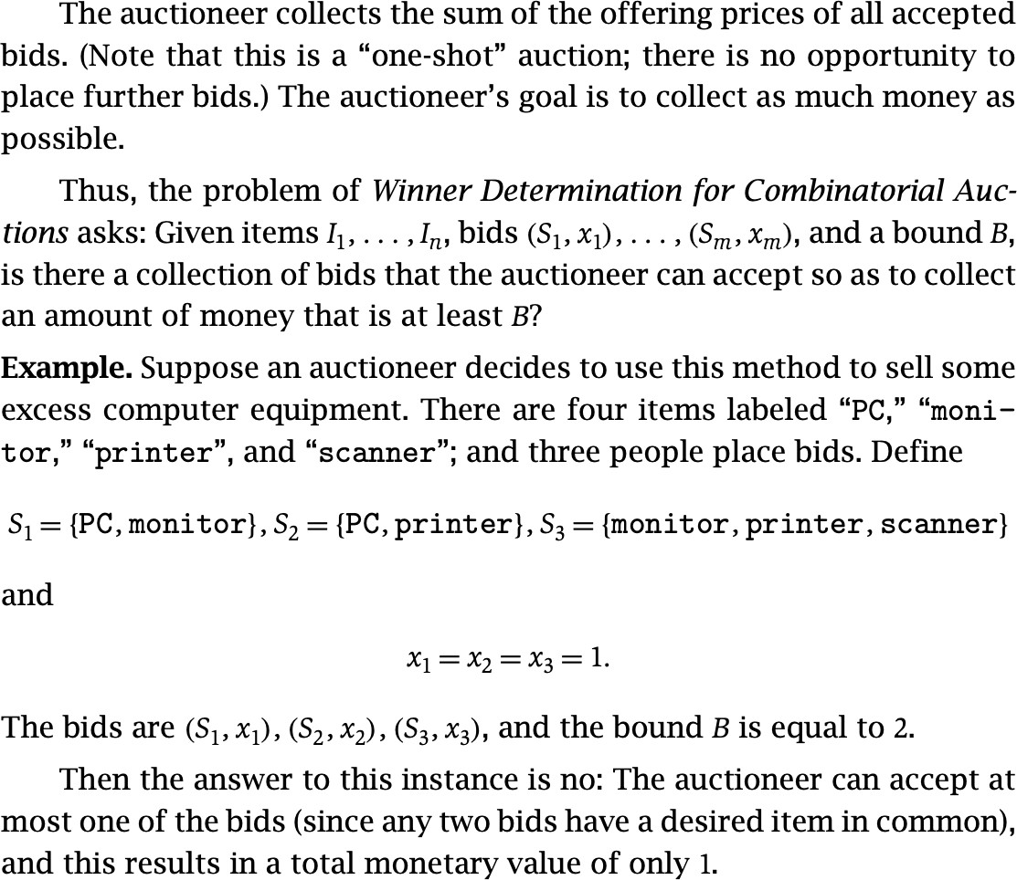

Prove that the problem of Winner Determination in Combinatorial Auctions is NP- complete. Reduce from Independent Set.

1. (25 points)

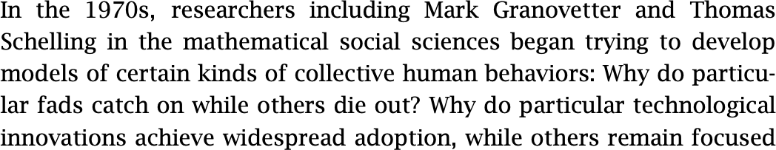

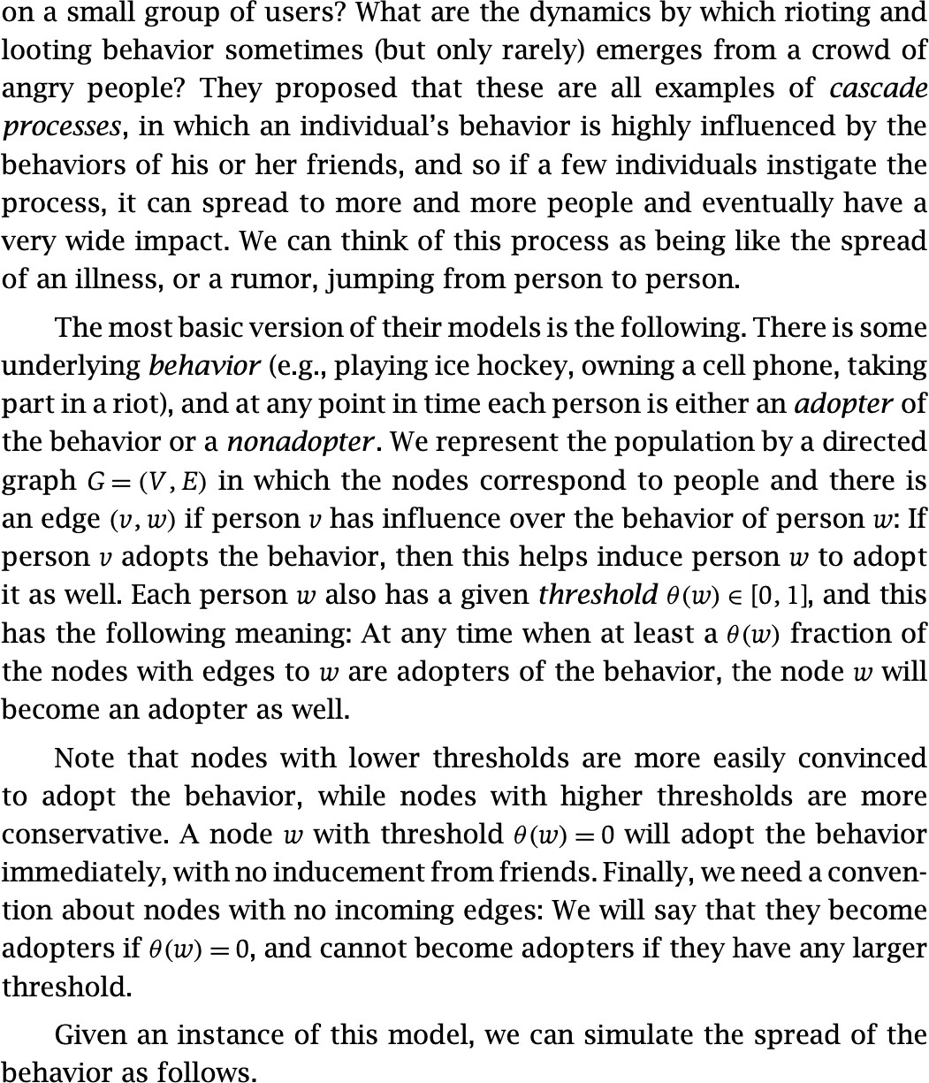

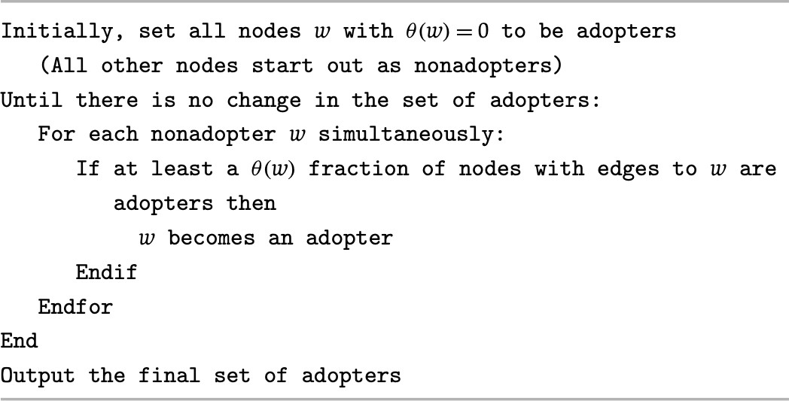

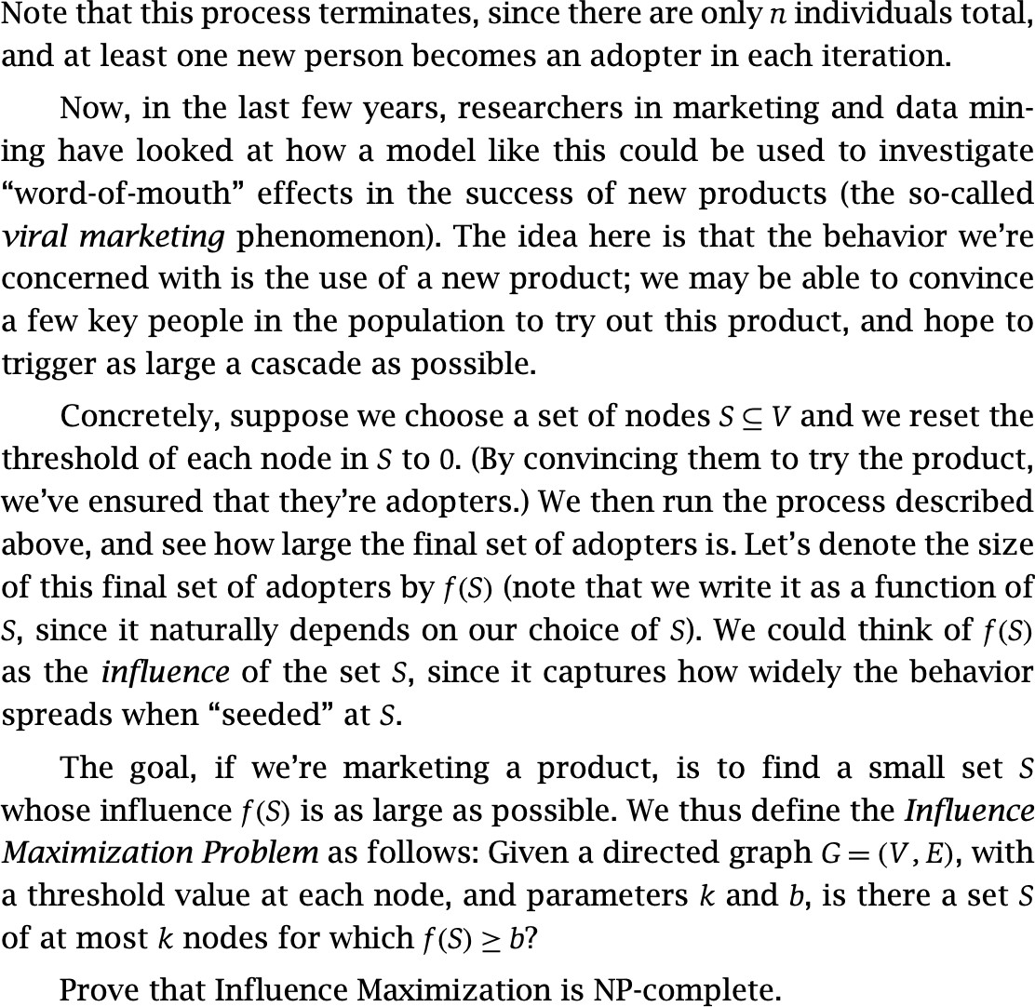

Reduce from Vertex Cover.

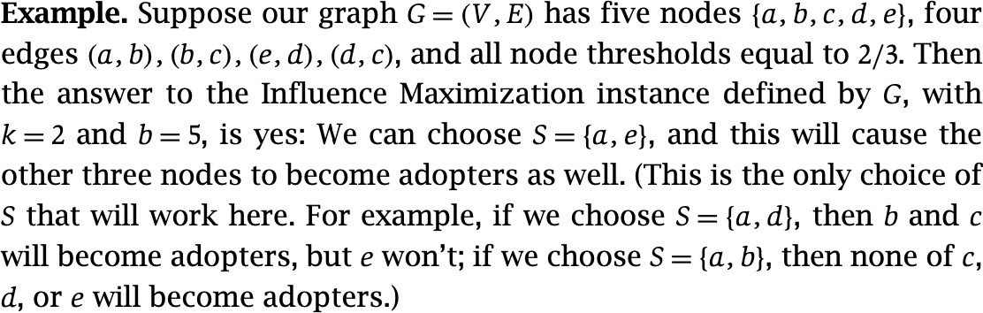

1. (25 points)

Madison is in preschool and has learned to spell some simple words. She has a colorful set of refrigerator magnets featuring the letters of the alphabet (some number of copies of the letter *A*, some number of copies of the letter *B*, and so on), and the last time you saw her the two of you spent a while arranging the magnets to spell out words that she knows. The two of you tried to spell out words so as to use up all the magnets in the full set – that is, picking words that she knows how to spell, so that once they were all spelled out, each magnet was participating in the spelling of exactly one of the words. (Multiple copies of words are okay here; so for example, if the set of refrigerator magnets includes two copies each of *C, A,* and *T*, it would be okay to spell out *CAT* twice.)

This turned out to be pretty diﬃcult, and it was only later that you realized a plausible reason for this. Suppose we consider a general version of the problem of *Using Up All the Refrigerator Magnets*, where we replace the English alphabet by an arbitrary collection of symbols, and we model Madison’s vocabulary as an arbitrary set of strings over this collection of symbols. The goal is the same as in the previous paragraph.

Prove that the problem of Using Up All the Refrigerator Magnets is NP-complete.

Reduce from 3D matching.

1. (Next Page)

4. (25 points)

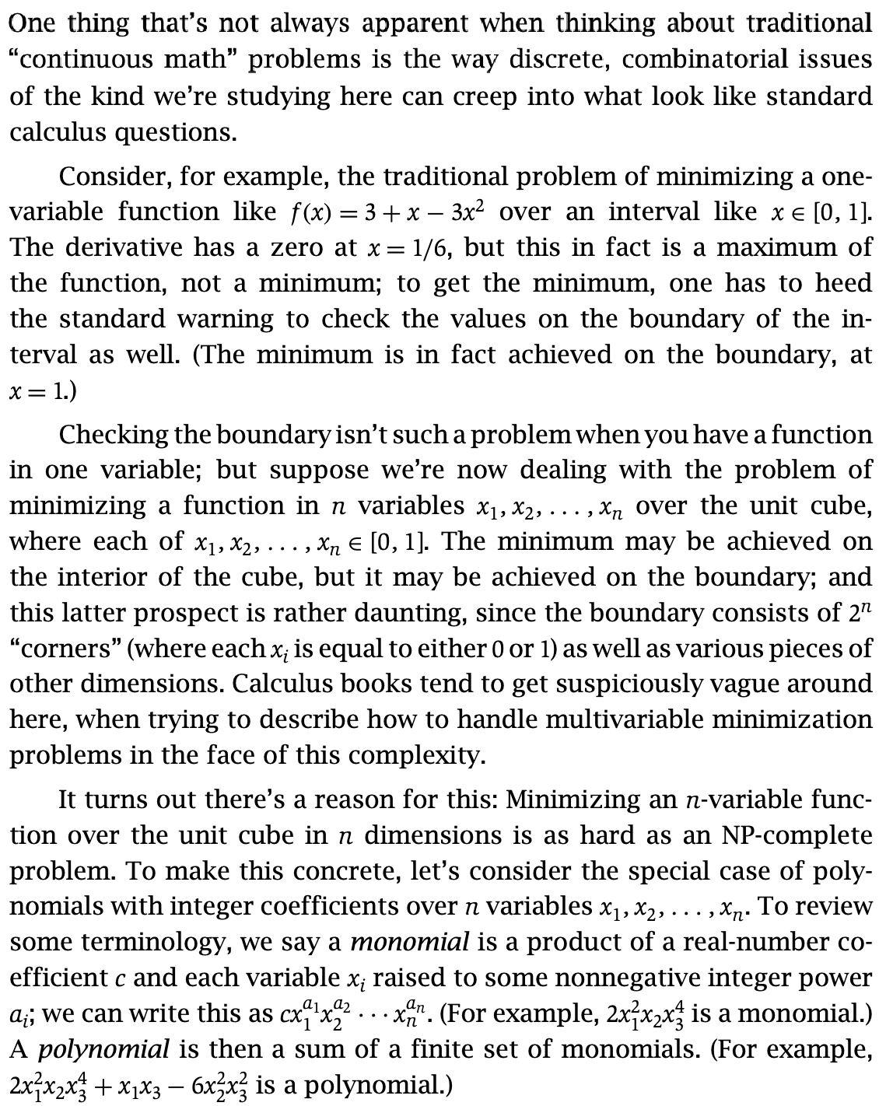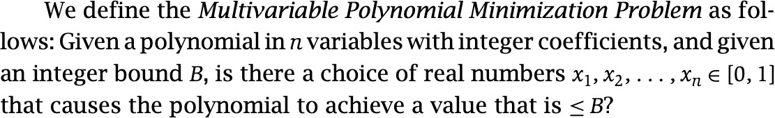

Prove that *Multivariable Polynomial Minimization* is NP-complete. Reduce from 3-SAT.